Single-Phase Half-Wave Controlled Rectifier with RL Load and Freewheeling Diode
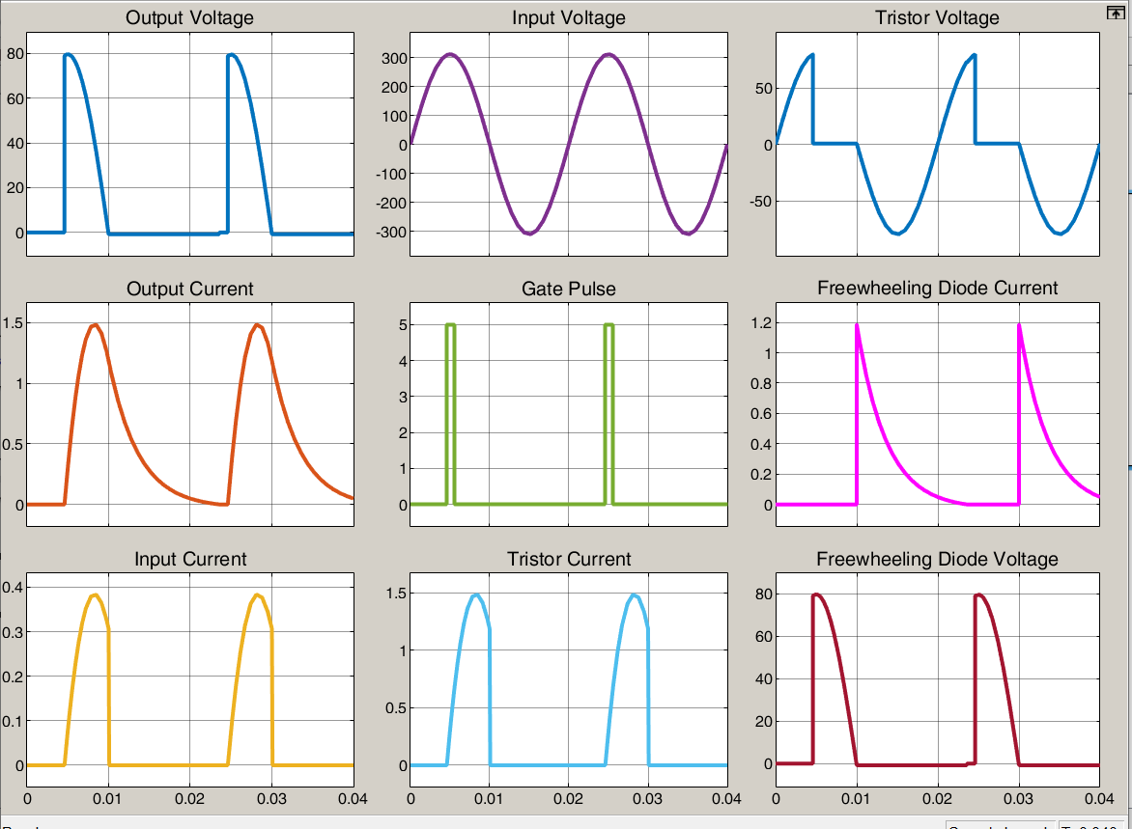

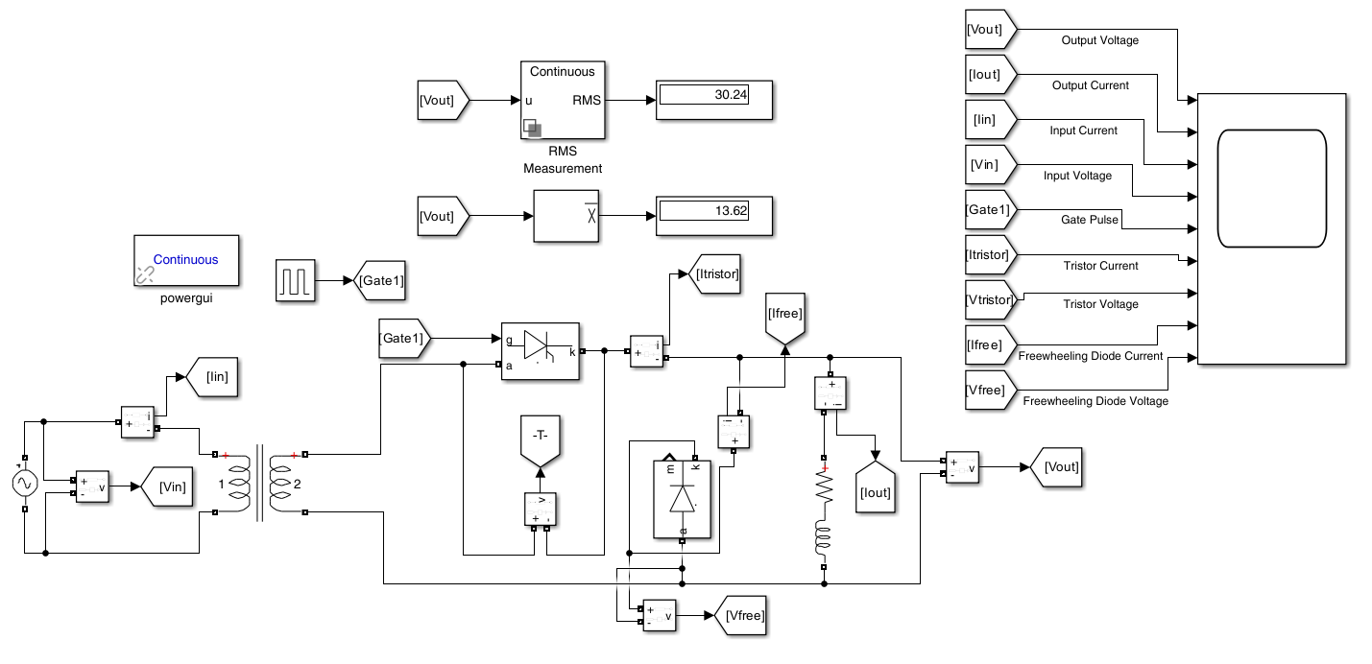

Single-Phase Half-Wave Controlled Rectifier with RL Load
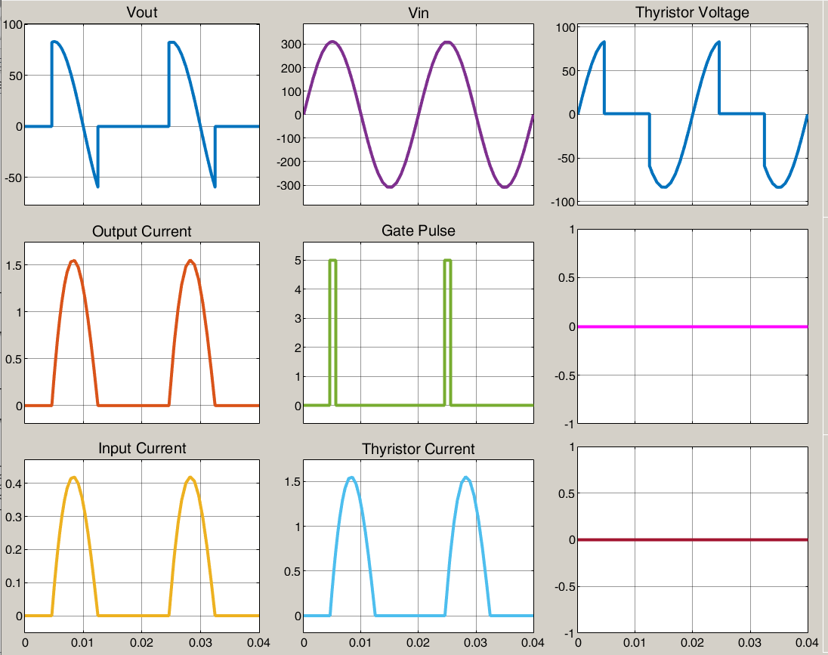

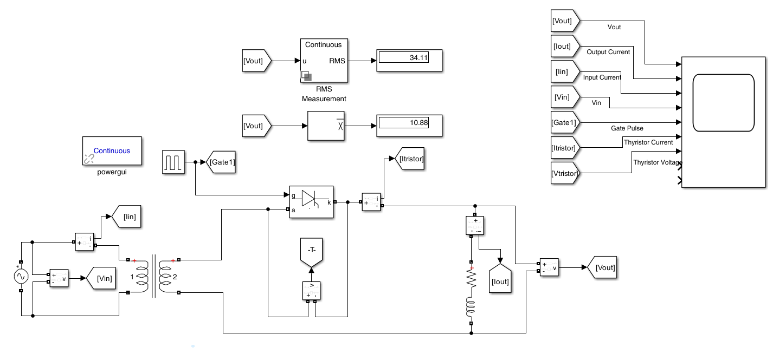

Single-Phase Full-Wave (Bridge) Controlled Rectifier
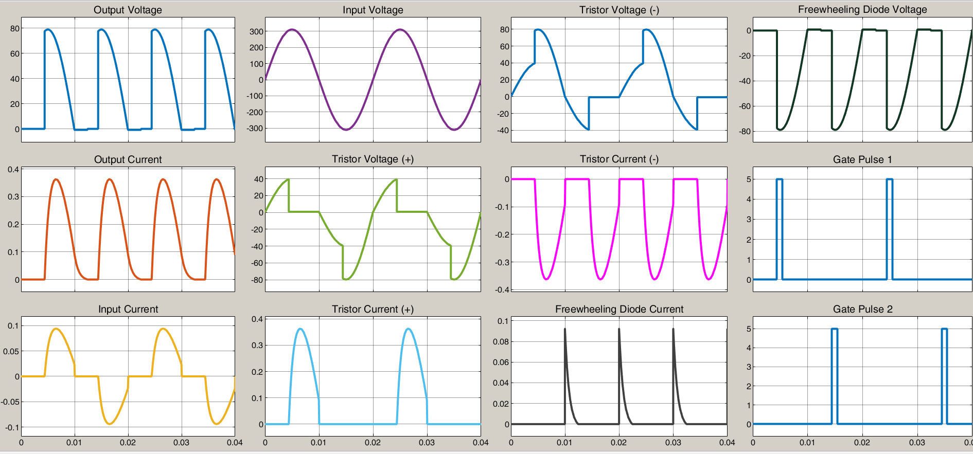
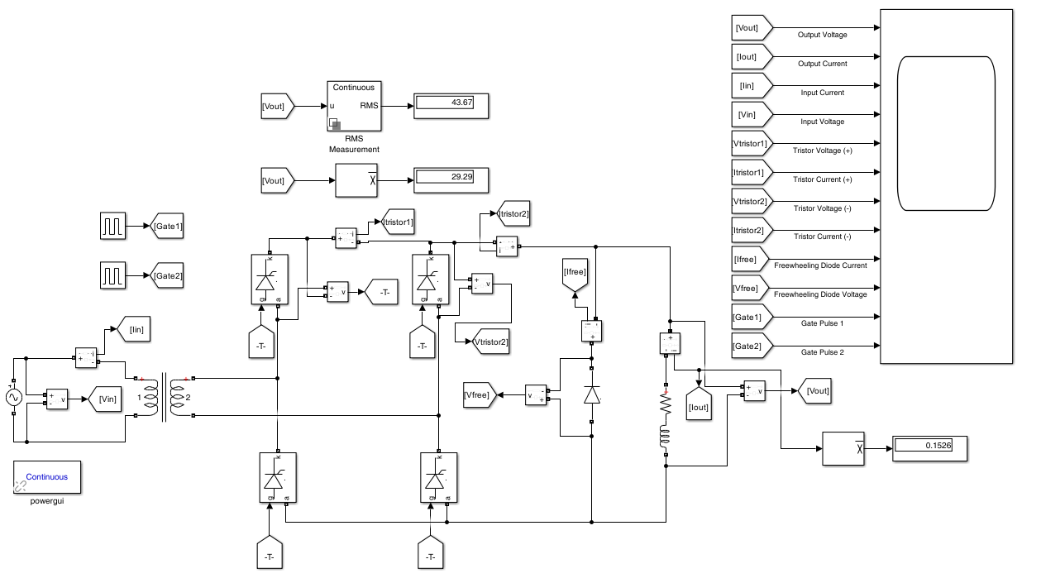

Single-Phase Full-Wave (Bridge) Uncontrolled Rectifier with a Capacitive Filter and R Load
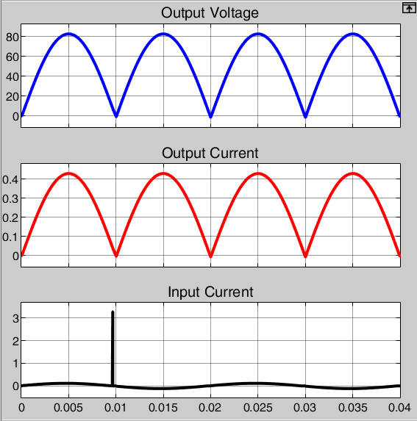
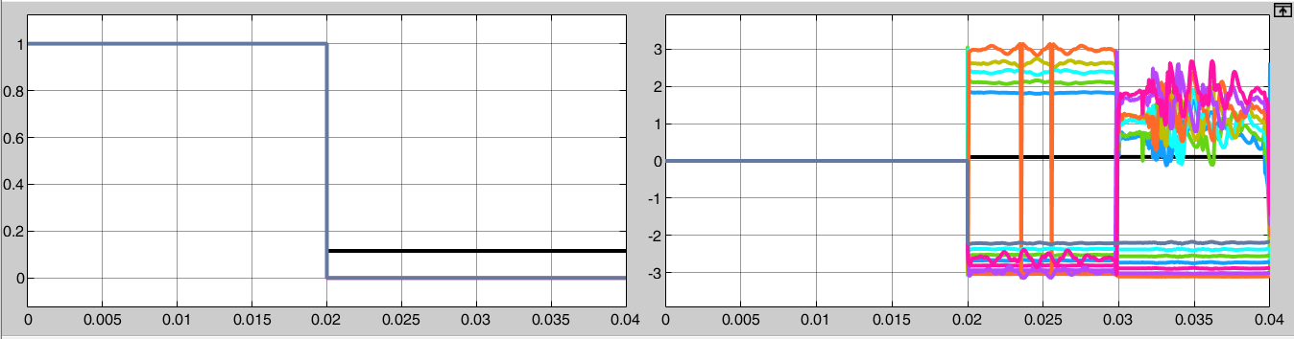
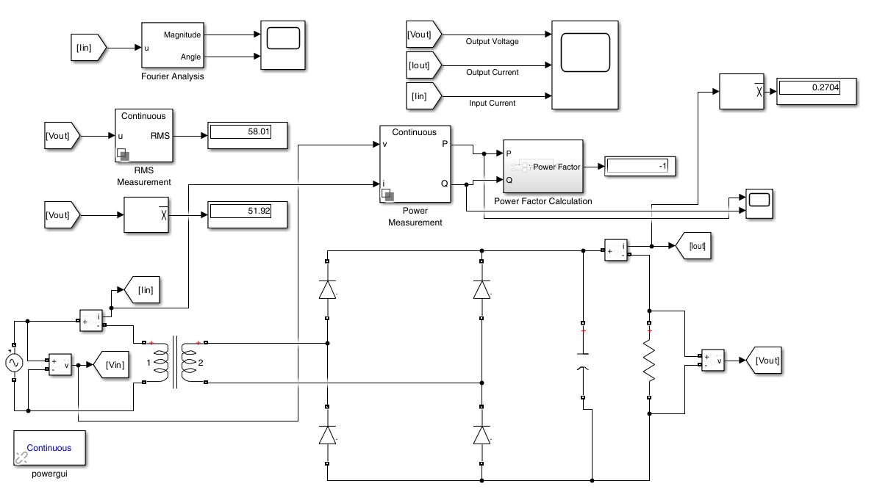

8. REFERENCES
[1] https://www.youtube.com/watch?v=nsUAmp45BUA&t=133s
[2] D. W. Hart, Introduction to Power Electronics, Prentice Hall, 1997.
[3] Mathworks Forum

